Experiment Eleven: PWM control of light intensity experiment
Width Modulation Pulse is commonly referred to as PWM, referred to as pulse width modulation, pulse width modulation (PWM) is a kind of analog signal level digital encoding method, because the computer can not output analog voltage, can only output 0 or 5V of digital voltage value, we use high resolution counter, the use of square wave duty ratio modulation method to a specific analog signal level, because at any given moment, full amplitude of the DC power supply or 5V (ON) (.PWM). Or 0V (OFF), voltage or current source is a ON (OFF) or the repetitive pulse sequence is added to the analog load up. When the DC power supply is added to the load, when the power is disconnected when the power supply is disconnected. As long as enough bandwidth, any analog value can be used PWM to encoding。Output voltage = (on time / pulse time) * maximum voltage value
.。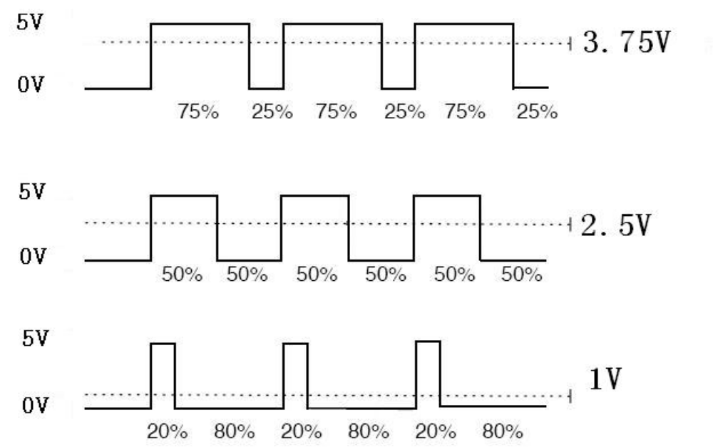
PWM is used in many places, dimming lamps, motor speed, sound production and so on.

Here are the three basic parameters of the PWM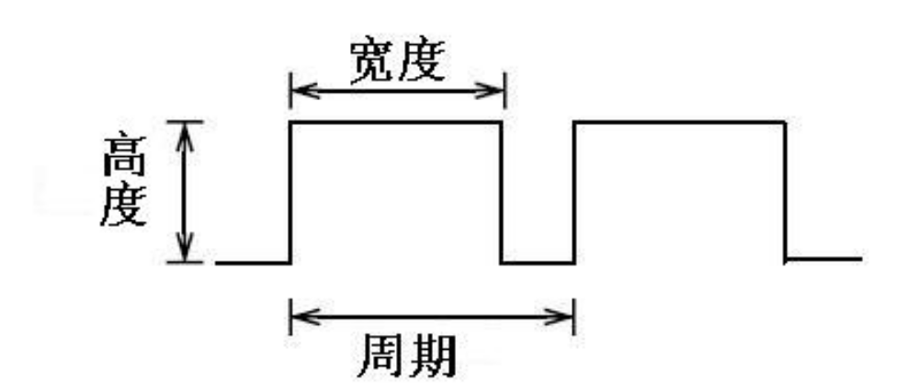
1、Pulse width change range (min / max)
2、Pulse period (reciprocal of the number of pulses within 1 sec)
3、Voltage height (for example: 0V-5V)
Arduino controller has six PWM interface are digital interface 3,5,6,9,10,11, front we have to do the experiments of the buttons to control the lights, it is digital signals to control the digital interface of the experiment, we did the experiment of the potentiometer, this time we have to finish with a potentiometer control of small lights in the experiment.
Required components：
Potentiometer module *1

The red line M5 LED*1

220 line resistance

Bread board *1

Bread board jumper *1 tie
Potentiometer is analog value input we received analog interface, the lights we received PWM interface, different PWM signal generated by this can allow a small lamp brightness changes.

We first in accordance with the following schematic diagram attached to the physical map.
We can also put 11 feet and 13 foot jumper together, we don't have to pick up LED line, is more convenient. The effect is the same.
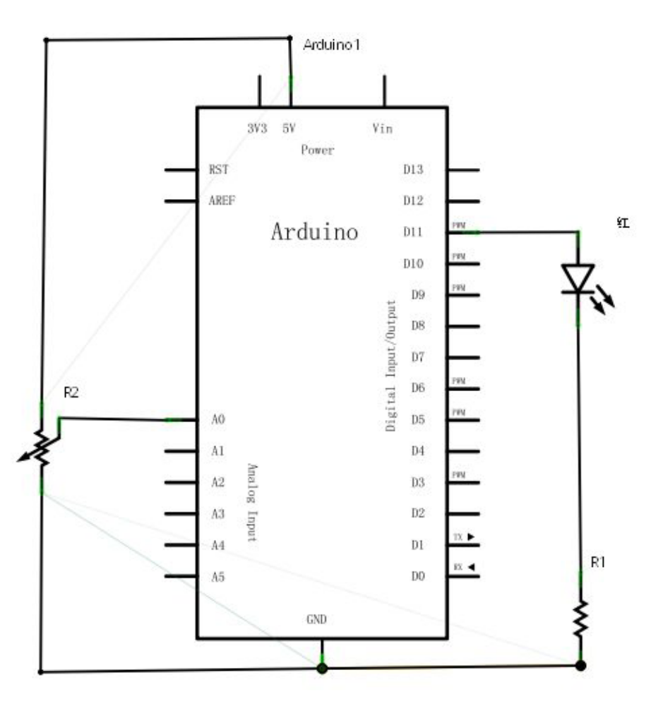
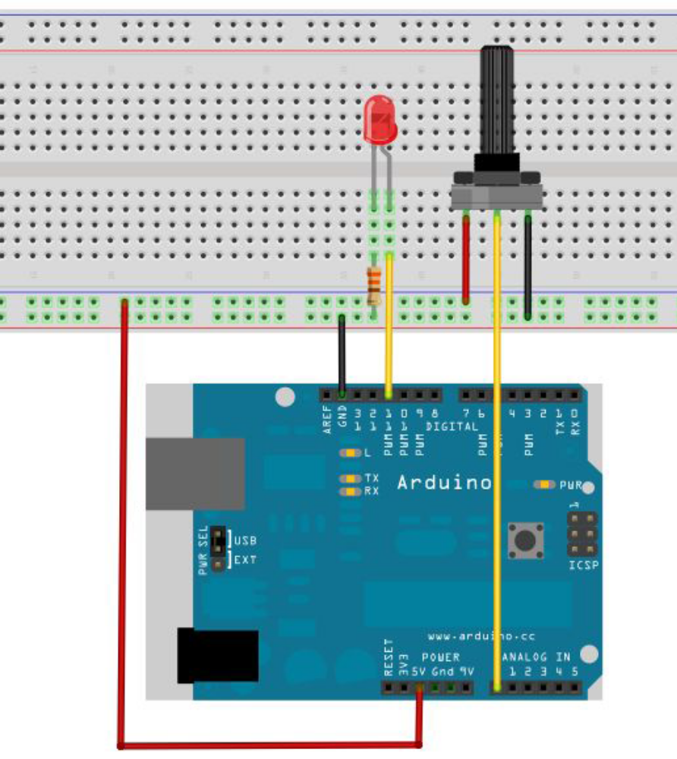
In the programming process, we will use simulation was written to analogwrite (PWM interface and simulation value) function, for simulation was written to analogwrite () function, this function usage is very simple, we in the read potentiometer analog signal value and will assign to the PWM interface, so that the small lights produce corresponding changes in brightness, again on the screen shows the simulated values read, we can understand that for this program is in the simulated values read experimental procedures with the analog value is assigned to a PWM interface this section below for everyone to provide a reference source program.
Reference source program：
int potpin=0;//Define analog interface 0
int ledpin=11;//Definition of digital interface 11 (PWM output)
int val=0;// From numerical temporary sensor variables
void setup()
{
pinMode(ledpin,OUTPUT);//Define digital interface 11 for output
Serial.begin(9600);//Set the baud rate to 9600
//Note: the analog interface is automatically set to the input
}
void loop()
{
val=analogRead(potpin);// Read the sensor's analog values and assign to val
Serial.println(val);//Display Val variable
analogWrite(ledpin,val/4);// Open the LED and set the brightness (PWM loss __________ maximum 255)
delay(10);//Delay 0.01 seconds
}
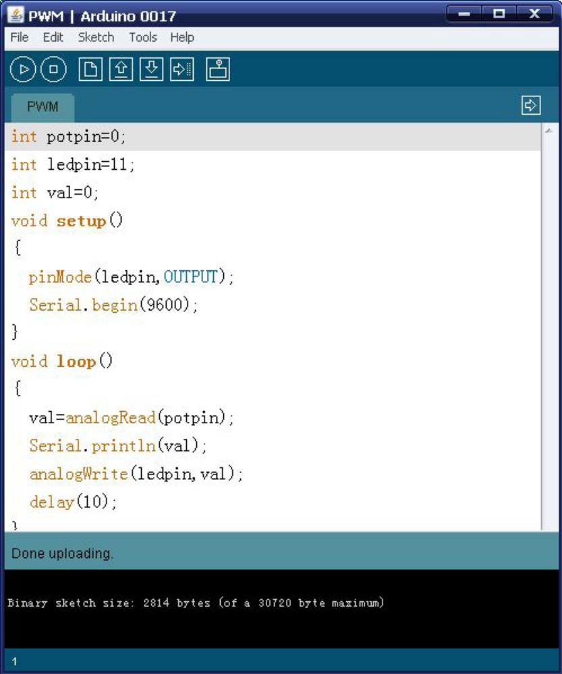
The downloaded program, we rotate the potentiometer knob can not only see screen numerical changes also can clearly see our bread board LED lamp brightness is in change.

